**Project Statement**

**(O LALA LAND)**

**Version 2, Week 6**

**Submitted by :**

**Client:** Mrs. Mieke Vucht

Fadi Abboud

Lokesh Agnihotri

Obaid Ghafoori

Wondimu Woldaeaarggiye

**Tutor**: Mr. Mikaeil Shaghelani Lor **Date:13**-10-2019

**Contents**

1. Version Table

2. Agreements made with the client

3. Processes

3.1 Buying a Ticket and Reserving a Camping Spot

3.2 Selling Food and Drink

3.3 Selling Souvenirs

3.4 Assigning Items for Loaning

3.5  Returning Loaned Items

3.6 Signing Visitors in the Event Area

3.7  Visitor Entering the Event

3.8 Visitor Leaving the Event Grounds

3.9 Returning to the Event

3.10 Entering the Camping Area

3.11 Exiting the Camping Area

3.12 Using Dashboard

4. Functional Requirements

4.1 MoSCoW

5. Applications GUI

5.1 Check in application

5.2 Check out application

5.3 Entrance application

5.4 Exit application

5.5 Loan shop application

5.6 Food shop application

5.7 Souvenir shop application

5.8 Camping entrance application

5.9 Camping exit application

5.10 ATM application

5.11 Login application

6.Website Wireframe

6.1 BUY TICKETS Page

6.2 VENUE Page

6.3 TERMS & CONDITION Page

6.4 Login Page

7.  Entity Relationship Diagram((ERD)

**1.Version Table**

|  |  |  |
| --- | --- | --- |
| Version | Tasks performed | Date |
| 1 | Setup document v1 | 24-09-2019 |
| 2 | Setup document v2 | 13-10-2019 |

**2.Agreements made with the client:**

1. For the event we should aim at collecting as little data as possible from the visitors.

2. All tickets have the same price and a single ticket.

3. The event is for 18 years or older.

4. The ticket is non-refundable .

5. The number of camping spots is 300.

6. The expected minimum number of the visitors is 500 maximum quotas would be 1000.

7. Visitors can add money on their event account through  the ATM machines at the event.

8. The event’s duration is from 14-06-2019 at 15:00 until 16-06-2019 at 22:00.

9. Applications should be three types – for the visitors, for the employees at the events and

for the client.

**3. Processes:**

In this set up document we describe all meaningful interaction between the system and the user. The users are the client, employees and the event participants.

**3.1 Use Case**: Buying a Ticket and Reserving a Camping Spot: Visitor

Main scenario:

1. The visitor opens the event website

2. The visitor buys a ticket from the website

3. The visitor signs up on the page

4. The visitor login on the page

5. The visitor confirms the payment

6. The system answers in sending an email with the visitor ID to the visitor

***Extensions****:*

4b. The visitor does not reserve a camping spot.

- He/she can reserve a spot by paying additional fee of 10 euro on top of base fee.

**3.2 Selling Food and Drink**

Performer: Employee, Visitor

*Main scenario:*

1. The visitor scans their bracelet

2. Visitor adds edibles and drinks to

3. The visitor approves the order

4. The system deduct an amount from the visitor account and print a receipt

***Extensions***

3b. The visitor requests to cancel some of the orders

3c. The visitor account doesn’t have enough money

- The visitor informed their account status by the system

- The system cancels the visitor order

- The visitor add money to their event account  through ATM Machine

- The visitor reorders the items and confirm the order

- The system deducts an amount from the visitor account and print a receipt

**3.3  Selling Souvenirs**

Performer: Employee, Visitor

*Main scenario:*

1. The visitor scans their bracelet

2. The employee host products to the visitor’s

3. The visitor approves the order

4. The system deducts an amount from the visitor account and print a receipt

***Extensions:***

3a. The visitor cancels the whole order

- Doesn’t  deduct an amount from the visitor account

3b. The visitor requests to cancel some of the orders

- The employee updates  the new order

3c. The visitor account doesn’t have enough money

- The visitor informed their account status by the system

- The system cancels the visitor order

- The visitor add money to their event account  through ATM Machine

- The visitor reorders the items and confirm the order

- The system deducts an amount from the visitor account and print a receipt

**3.4  Get items by loan**

Performer: Employee, Visitor

Main scenario:

1. The visitor scans their bracelet

2. The employee hosts the items for the visitor

3. The visitor confirms the loan

4. The system deducts an amount from the visitor account and print a receipt .

***Extensions:***

3a. The visitor cancels the whole order

- Doesn’t  deduct an amount from the visitor account.

3b. The visitor requests to cancel some of the orders.

- The employee updates  the new order.

3c. The visitor account doesn’t have enough money.

- The visitor informed their account status by the system.

- The system cancels the visitor order.

- The visitor add money to their event account  through ATM Machine.

- The visitor reorders the items and confirm the order.

- The system deducts an amount from the visitor account and print a receipt.

Performer: Employee, Visitor

*Main scenario:*

1. The visitor scans their bracelet.

2. The employee scans products, removing them from the visitor’s account.

***Extensions:***

2a. The visitor decides to cancel the whole returning.

- The employee clicks on the “Reset session” button.

2b. The visitor wants to cancel the returning of a specific item.

- The employee clicks on the “Reset session” button.

**3.6 Signing Visitors in the Event Area**

Actors: Employee, Visitor

*Main scenario:*

1. The employee checks the ID of the visitor to ensure they are above 18 years old.

2. The visitor provides their visitor ID (barcode).

3. The employee scans the visitor ID and the visitor’s credentials appear on the screen.

4. The employee scans a bracelet linking it to the visitor’s account.

***Extensions:***

1a. The visitor is below 18 years old.

- The visitor is not let inside the event grounds.

2a. The visitor does not have an account.

- The visitor is asked to create an account (a device with the website is provided on the spot for people with no phones).

3a. The employee scans the barcode, but the visitor does not have an event account (provides a fake barcode).

- An error is displayed, and the visitor get updating from employee and further is asked to either create an event account or leave; The visitor’s credentials do not appear on the screen.

**3.7  Visitor Entering the Event**

Actors: Visitor

*Main scenario:*

1. The visitor scans their bracelet on the gate scanner.

2. The gate of the event opens and lets the visitor in.

***Extensions:***

1a. The visitor uses an entrance gate, but the gate does not open.

- A message “Please, scan again!” appears on the display.

**3.8 Use Case: Visitor Leaving the Event Grounds**

Actors: Employee, Visitor

*Main scenario:*

1. The visitor scans their bracelet in order to open the “Temporary exit” gates

2. The gates open to let the visitor out.

***Extensions:***

1a. The visitor scans their bracelet in order to open the “Permanent exit” gates:

- The gates open to let the visitor out.

- An employee asks for the visitor’s bracelet in order to remove the visitor’s ID from it.

1b. The visitor uses the “Permanent exit” without returning the loaned items.

- The scan screen displays a message that the visitor has loaned items.

1c. The visitor is not allowed to leave until they return their loaned items.

1d. The visitor uses any of the exits and the door does not open.

- A message “Please, scan again!” appears on the display.

**3.9  Returning to the Event**

Actors: Employee, Visitor

*Main scenario:*

1. The visitor comes back and scans their bracelet to open the “Temporary exit” gates.

2. The gates open to let the visitor back in the event.

***Extensions:***

1a. Ask a guard for a manual check and back to the event.

**3.10  Entering the Camping Area**

Actors: Visitor, Employee

*Main scenario:*

1. The visitor scans their bracelet on the door scanner of the camping area.

2. The door opens and lets the visitor in.

***Extensions:***

1b. The visitor scans their bracelet more than once:

- The door does not open. A message describing the problem and asking for speaking with an employee appears on the screen.

- An employee opens the door for the visitor.

**3.11 Exiting the Camping Area**

Actors: Visitor, Employee

*Main scenario:*

1. The visitor scans their bracelet on the door scanner of the camping area

2. The door opens and lets the visitor out

**Extensions:**

1b. The visitor scans their bracelet more than once:

- The door does not open. A message describing the problem and asking for speaking with an employee appears on the screen.

- An employee opens the door for the visitor.

**3.12 Use Case: Using Dashboard**

Actors: Client

*Main scenario:*

1.Without the need to register, the client logs into the website using their email and password

2.The DASHBOARD page automatically loads

***Extensions:***

1b. The client cannot enter their account

-The client can contact the developer team and ask for help.

**4.Functional Requirements**

In this section, the website and the applications will be prioritized (using MoSCoW) based on the importance of their functions.

**4.1 MoSCoW**

MoSCoW is a prioritization method. It stands for Must have, should have, could have and Won’t have.

Here is a description of the categories:

**Must have**

Requirements labelled as Must have are crucial for delivering before the current deadline.

**Should have**

Requirements labelled as Should have are important to deliver before the current deadline but are not a big thread for the whole project.

**Could have**

Requirements labelled as Could have are not of great importance for the current deadline.

**Won't have (this time)**

These are requirements which the project team has agreed will not be delivered as part of this timeframe.

Since the MoSCoW method uses timeslots, for the current time slot (block one of the second semesters) the requirements could be graded as follows:

**Must have Properly working applications**

A fully functioning website

A public database, communicating with both the applications and the website

**Should have**

iDeal payment method.

Sign in and sign up.

Online booking.

**Could have**

Different payment method.

Lost and found page.

Ticket per day.

**Won’t have**

Group ticket or VIP ticket.

**5. Applications GUI**

This section will provide images and description of the applications.

**5.1 Check-in application**

This application will be used at the entrance of the event. The visitors who have registered online can scan their bracelet at the entrance to enter the event.

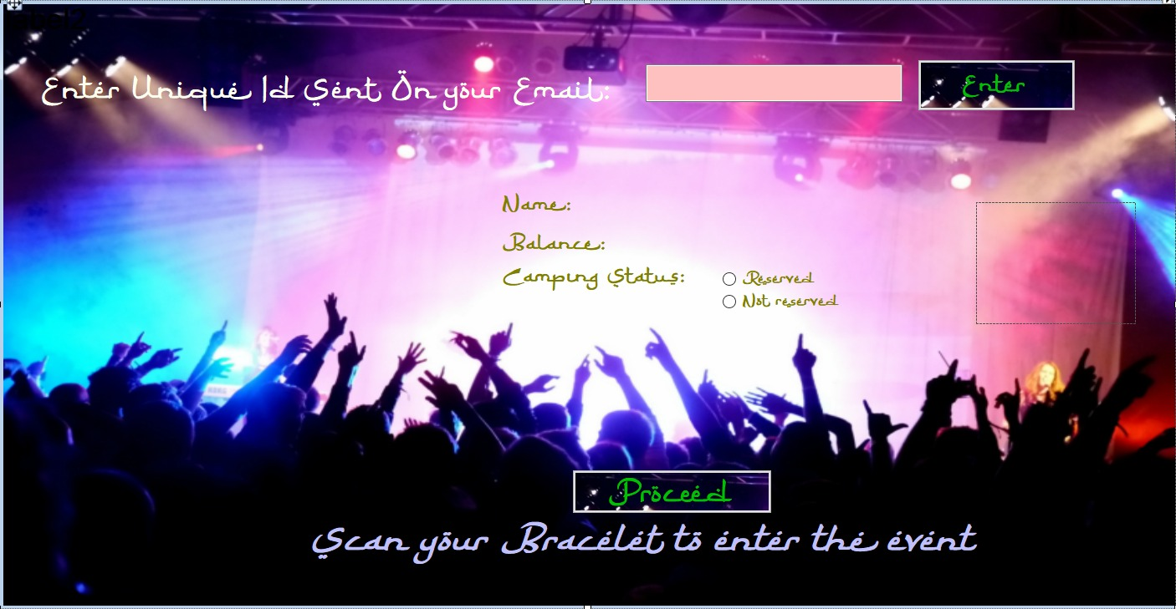

For visitors who did not buy the ticket online can come to the reception at the entrance of the event gate. An employee there can take their details update it on the database using this app.

Once updated, visitor can scan their bracelet and enter.

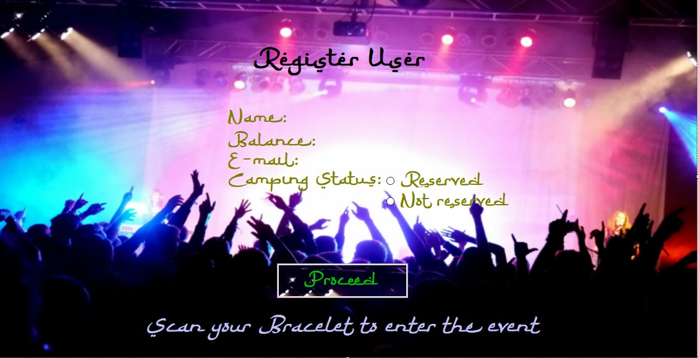

**5.4 Exit application**

This application will allow a visitor with no loaned items to leave the event. The gates of the event open when the bracelet is scanned, and the visitor does not have any loaned items on their event account. The application again prevents from cheating.

The loan shops will use this application. The main screen will have no buttons, it will only ask for the visitor to scan their bracelet. When they scan it for the first time, the screen below appears. If they have some loaned items on their account, the screen above appears.

The “Loan product” button leads to the “Loan screen” and the “Return product” button to the “Return screen”.

The “Loan screen” will display a list box with the scanned items for this order of the visitor. The application also shows the total cost of all items added to the order. Scanning an item for the second time will remove it from the current order. The “Cancel order” button clears the whole list and the “Finalize order” button deducts the items’ cost from the account.

The “Return screen” is used to return loaned items. The employee sees a list of the items that the visitor has loaned on the left. On the right there is a list of items for returning. After scanning an item, it disappears from the left list and appears on the right. The button “Mark as damaged” removes an item from the list, marks it as damaged and also makes it impossible for further loaning. The button “Finalize” will permanently return the items in the right list box.

**5.5 Food shop application**

The main screen of the application shows a message to the visitor to scan their bracelet after which the screen above appears.

On the top left of the shop application there are two buttons – “Food” and ”Drink”. Clicking on the “Food” button displays all the food available in the shop in the middle of the screen. Clicking on the “Drink” button displays all the drinks available in the shop. On the right there is a list that shows all the products that the visitor adds to their order. The application also shows the total cost of all items added to the order and the visitor’s balance.

The button “Keyboard” displays (or hides) a keypad with the numbers, a button “-” and a button “*”. Clicking on the “*”, a number and scanning an item (or selecting it from the menu) will result in adding it that many times. Similarly, clicking on the “-”, a number and scanning an item (or selecting it from the menu) will result in removing it that many times.

The “Cancel order” button clears the whole list (also shows the main screen again) and the “Finalize order” button deducts the cost of the items from the account (also shows the main screen again).

**5.7 Souvenir shop application**

The main screen of the application asks the visitor to scan their bracelet after which the screen above appears. The employee scans the wanted item and it appears on the list.

The keyboard works the same way as in the food shop application.

Clicking on the button “Finalize order” results in deducting the cost of all items from the visitor’s account and shows the main screen again. Clicking the button “Cancel order” clears the list of all items and shows the main screen.

**5.8 Camping entrance application**

This application does not have a GUI. Its functionality is to allow visitors to scan their bracelet and open the door of the camping area. Also prevents from cheating.

The Gui of this look just like the GUI for check-in

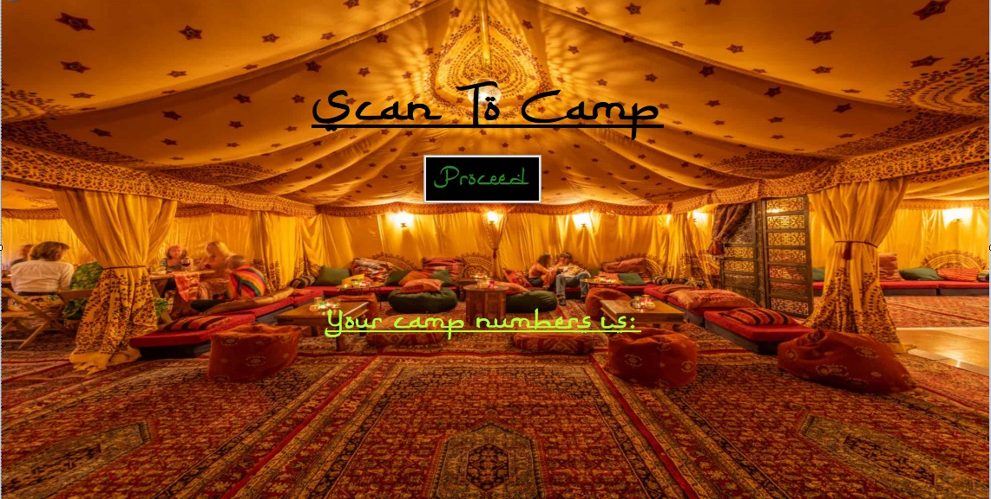

**5.9 Camping exit application**

This application does not have a GUI. Its functionality is to allow visitors to scan their bracelet and open the door of the camping area. Also prevents from cheating.

The GUI for this application will be the same as the GUI for check-out.

**5.10 ATM application**

This application does not have a GUI. Its functionality is to translate ATM log files and update the database. It runs as a process in the background and waits for log files to be sent to a specific folder.

**6.Website Wireframe**

This section will contain the website’s wireframes and description of each page.

**6.1 BUY TICKETS Page**

The “Buy tickets” page allows the visitors of the event to buy tickets and reserve camping spots. This results in creating an event account. Buying more than one ticket and reserving a spot for more than one person is possible through dropdown menus. After selecting number of tickets and camping spots, extra fields for credentials appear.

Clicking on a button “Proceed” opens a side menu which shows the number of tickets that the visitor has added to their cart, as well as the total amount the visitor must pay (plus the camping spot). The visitor should type their bank account in order to pay for their purchase.

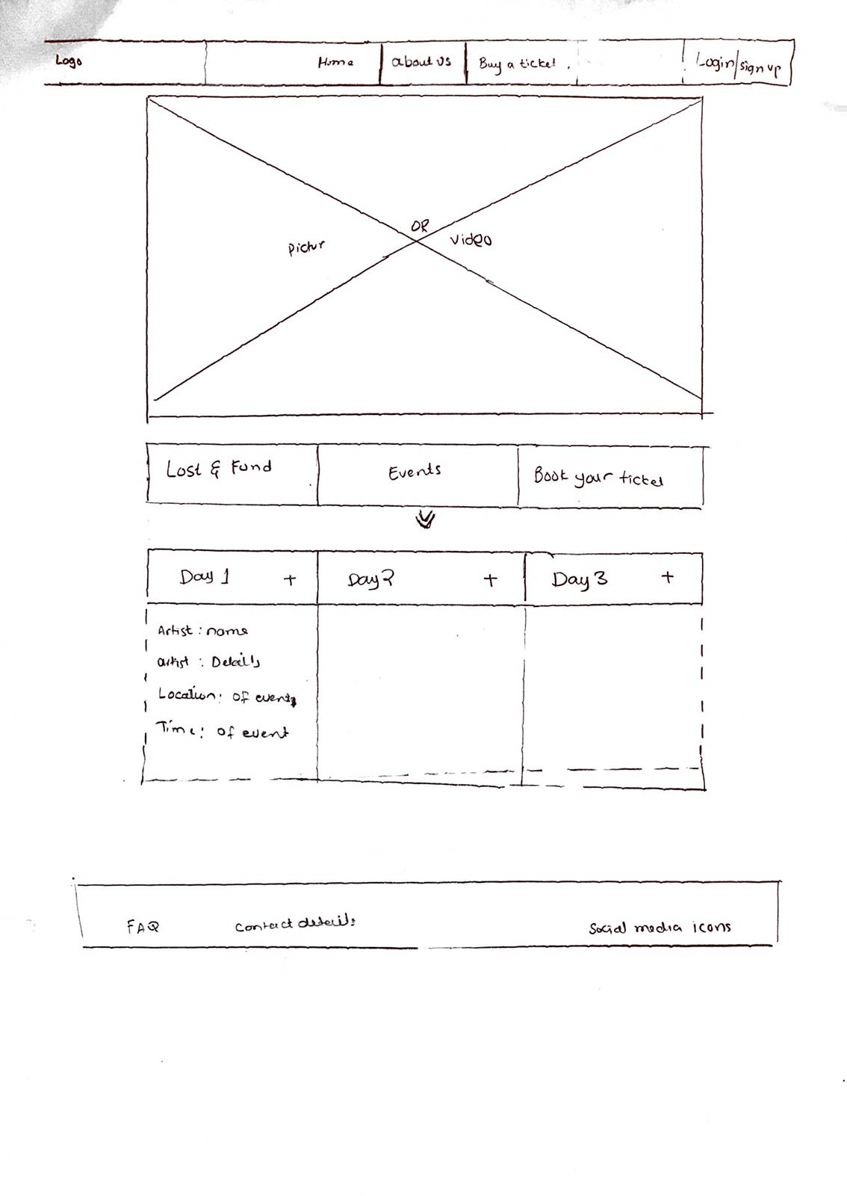

**6.2 Login Page**

The “Login” page asks for the visitor’s credentials and allows for the visitor to enter their account and check their balance for example.

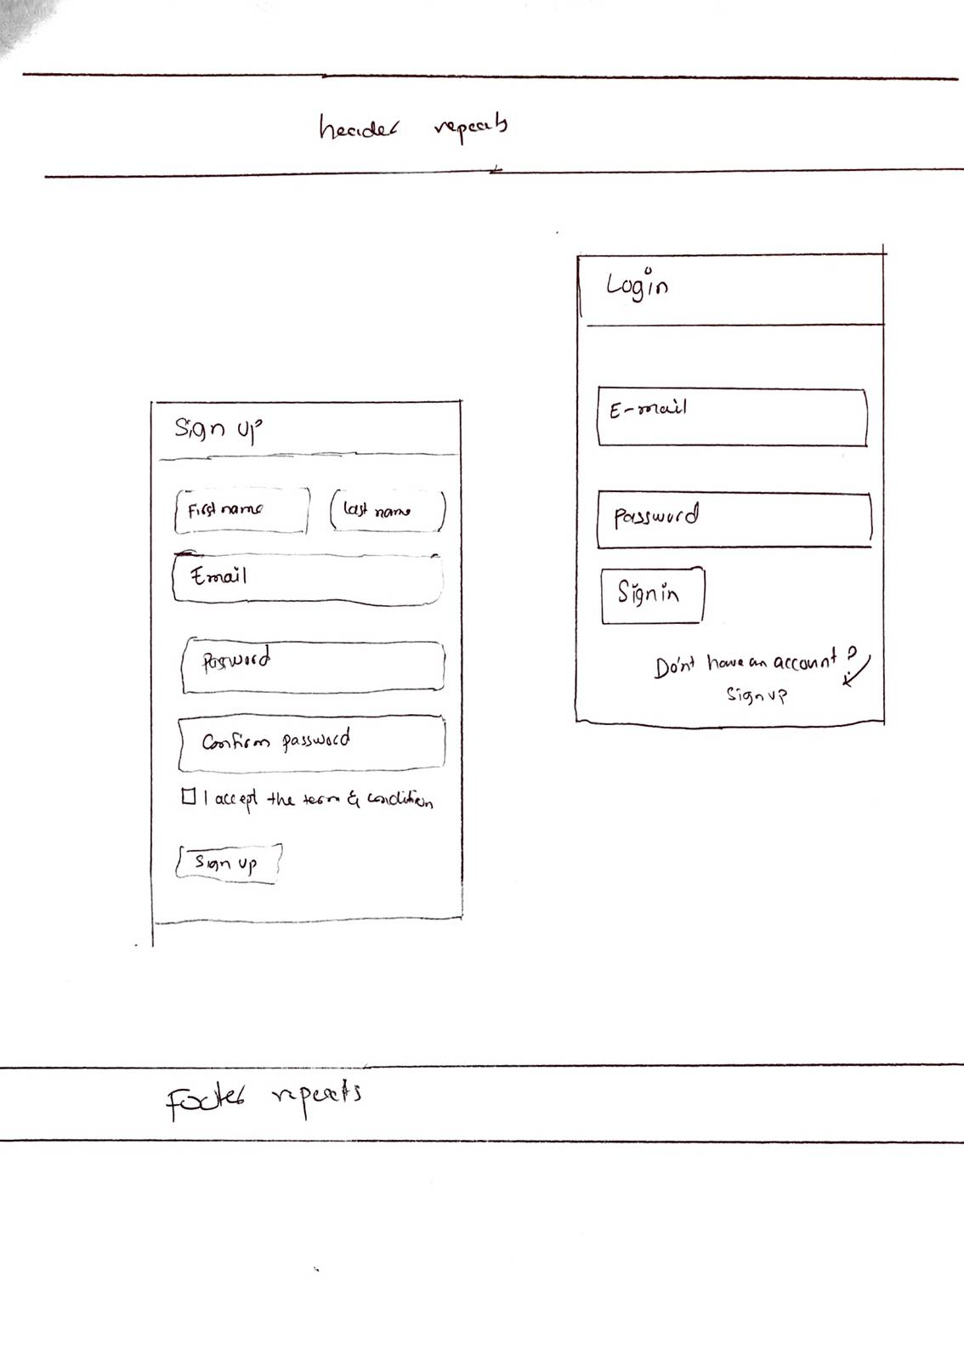

**6.3 Lost & found Page**

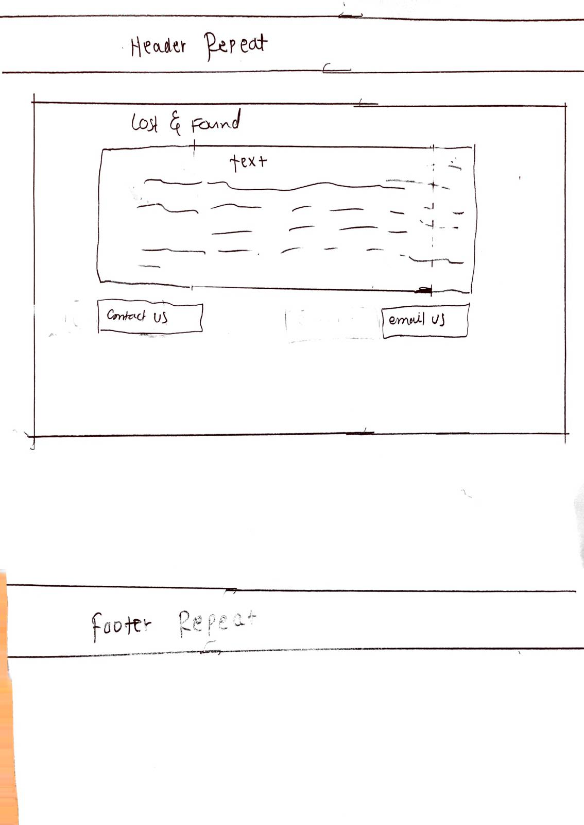

**7.ERD**

